CSA1509-Cloud computing and Big Data Analytics
Name : Nethra JB
Reg.no: 192524272

EXP 14 : Demonstrate virtualization by Installing Type-2 Hypervisor in your device, create and configure VM image with a Host Operating system (Either Windows/Linux).
Aim:
To Create a Virtual Hard Disk and allocate the storage using VM ware
Workstation.
Steps:
- Download VMware software and install it as Type-2 Hypervisor.
- Download Ubuntu or tiny os as ISO image file.
- In VMware workstation Create new VM
- Do the configuration based on given conditions
- Created a virtual Machine .
- Launch the VM.
Implementation:
- Download and open VMware software.
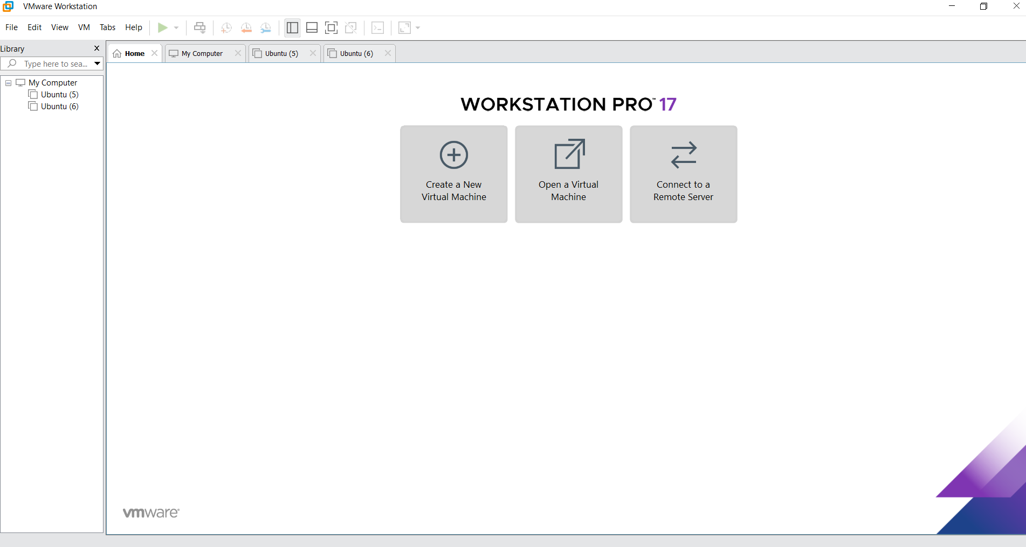

2.Create a new VM
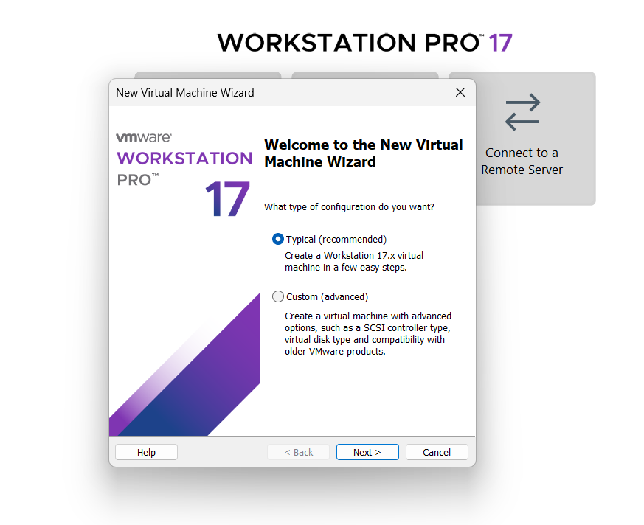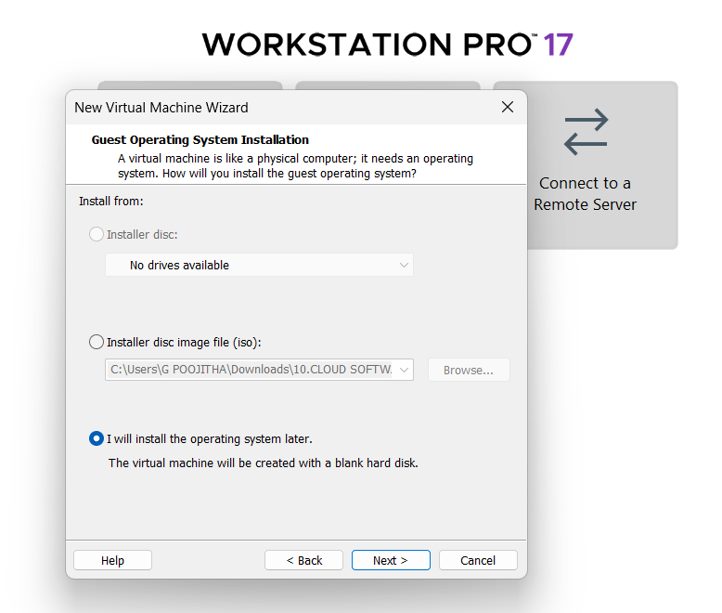
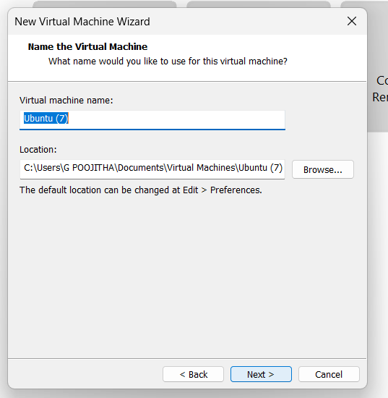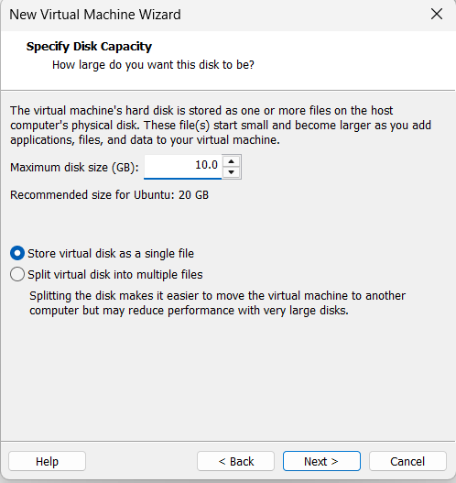
Name it anythingclick on nextAdjust the size of disk change the option to first and then click on next.
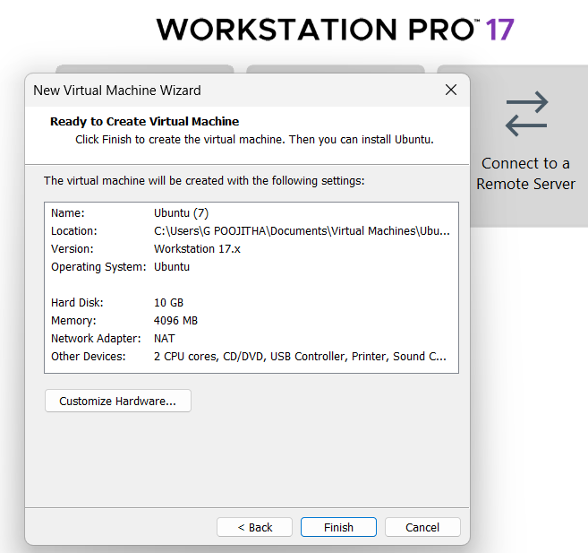

Click on Finish to Launch.
3.VM is created
